# sudo apt update

# cd /opt

# sudo apt install openjdk-17-jdk-headless -y

# sudo apt install wget unzip -y

# sudo wget https://dlcdn.apache.org/tomcat/tomcat-10/v10.1.20/bin/apache-tomcat-10.1.20.zip

# sudo unzip apache-tomcat-10.1.20.zip

# cd apache-tomcat-10.1.20/bin/

# sudo ln -s /opt/apache-tomcat-10.1.20/bin/startup.sh /usr/bin/startTomcat

# sudo ln -s /opt/apache-tomcat-10.1.20/bin/shutdown.sh /usr/bin/stopTomcat

# chmod u+x /opt/apache-tomcat-10.1.20/bin/*.sh

# sudo chmod u+x /usr/bin/startTomcat

# sudo chmod u+x /usr/bin/stopTomcat

# startTomcat

Server1

<http://15.206.171.130:8080/>

<http://15.206.171.130:8080/sample/>

server2

<http://13.235.241.27:8080/>

<http://13.235.241.27:8080/sample/>

server3

<http://65.2.128.166:8080/>

<http://65.2.128.166:8080/sample/>



# cd /opt/apache-tomcat-10.1.20/webapps/

# sudo wget <https://tomcat.apache.org/tomcat-7.0-doc/appdev/sample/sample.war>

Install and configure ngnix

# dnf install https://dl.fedoraproject.org/pub/epel/epel-release-latest-9.noarch.rpm

# sudo yum install nginx

# systemctl enable nginx.service

# systemctl start nginx.service

# systemctl status nginx.service

13.233.231.83:80

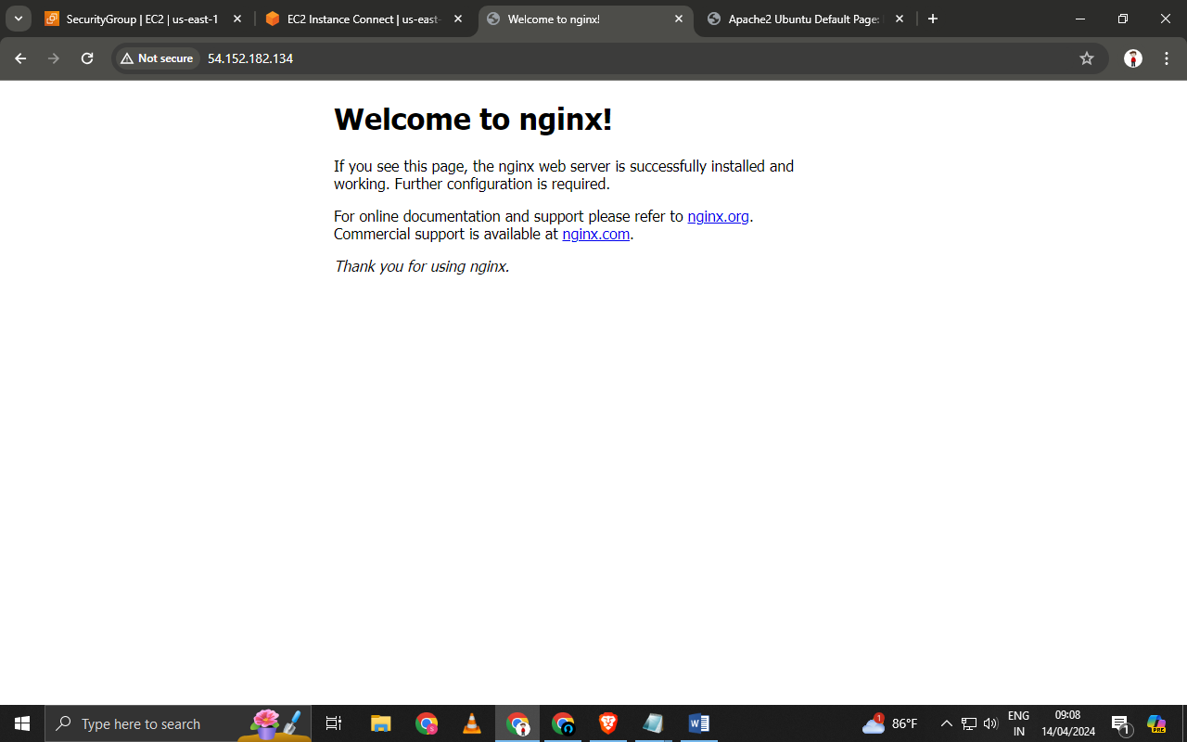

# cd /etc/nginx/

# ls

# mv nginx.conf nginx.conf_back

# ls

# vi nginx.conf

-----------------------------------------------------------------------------------------------------

events{

worker_connections 1024;

}

http {

keepalive_timeout 5;

upstream tomcatServers {

keepalive 50;

server 15.206.171.130:8080;

server 13.235.241.27:8080;

server 65.2.128.166:8080;

}

server{

listen 80;

location / {

proxy_set_header X-Real-IP $remote_addr;

proxy_set_header X-Forwarded-For %proxy_add_x_forwarded_for;

proxy_set_header X-Forwarded-Proto $scheme;

proxy_set_header Host $host;

proxy_pass http://tomcatServers;

}

}

}

-------------------------------------------------------------

#nginx -t

nginx: the configuration file /etc/nginx/nginx.conf syntax is ok

nginx: configuration file /etc/nginx/nginx.conf test is successful

# nginx -s reload

# systemctl restart nginx



This will throw error while selinux(Security Enhnance linux) is enabled .

# setsebool -P httpd_can_network_connect true



<http://13.233.231.83/sample/>

